

Pulse Oximeter Design Report

Made by

Group 2

Submitted on the

**GROUP 2**

**AM LUKUMBI removed**

**DELETED removed**

**DELETED removed**

**DELETED removed**

20 - 09 - 2021

# Anti-Plagiarism Declaration

**University of Johannesburg**

1. Plagiarism is to present someone else’s ideas as our own. Where material written by other people has been used (either from a printed source or from the internet), this has been carefully acknowledged and referenced. We have used the IEEE referencing style. Every contribution to and quotation from the work of other people in this essay has been acknowledged through citation and reference.

**By undertaking this report, we are deemed to have made and understood the following declarations:**

2. We know that plagiarism is wrong.

3. We understand what plagiarism is and am aware of the University’s policy in this regard.

4. We know that we would plagiarize if we do not give credit to our sources, or if we copy sentences or paragraphs from a book, article, or Internet source without proper citation.

5. We know that even if we only change the wording slightly, we still plagiarize when using someone else’s words without proper citation.

6. We declare that we have written our sentences and paragraphs throughout this report, and we have credited all ideas we have gained from other people’s work.

7. We declare that this assignment is our own original work.

8. We have not allowed and will not allow anyone to copy our work with the intention of passing it off as his or her own work.

Table of Contents

Anti-Plagiarism Declaration 2

List Of Tables and Figures 4

1 Background information on oximeter 5

1.1 Transmissive oximetry working principle 6

1.2 Reflective oximetry working principle 6

1.3 High Level Capability Architecture 6

2 Technical design 7

2.1 Technical components 7

2.2 Explanation on choice of components within application 7

2.2.1 Proximity Sensor 7

2.2.2 Oxygen saturation and Heart rate sensor 8

2.2.3 Central Processing Unit 8

2.2.4 Display 8

2.2.5 Signal Processing Unit (Resistor, Capacitor and Op-AMP(LM741)) 8

2.2.6 Switch 9

2.3 Methodology to be used to verify effectiveness of pulse oximeter 10

2.3.1 Calculation of SpO2(%) 12

3 PCB design 13

4 3-D casing design 15

5 References 16

## **List Of Tables and Figures**

Table 1: Summary of verification method, 11

Table 2: Table: showing R values ad their corresponding SpO2 levels. 12

Figure 1: 1.3 High Level Capability Architecture. 6

Figure 2: Active High Pass filter [8]. 9

Figure 3: Calibration curve [5]. 12

Figure 4: Architectural Diagram. 13

Figure 5: Subsystem architectural/circuit diagram. 13

Figure 6: 3D casing design (view 2). 15

Figure 7: 3D casing design (view 1). 15

Figure 8: 3D casing design (view 4). 15

Figure 9: 3D casing design (view 3). 15

# Background information on oximeter

Oximetry is a scientific method used to surveil oxygen saturation in people’s blood. A basic explanation of this method is calculating the oxygen level in a blood stream by measuring the amount of light a patient’s fingertip can absorb. The measurements can also be performed using the user’s earlobe, forehead, and other parts of the body. These continuous measurements can be used to mathematically generate a waveform signal that represents the heartrate or pulse of the user or patient.

A typical pulse oximeter showing SpO2 and heart rate in bpm. The pulse oximeter has a display as the human-machine interface. The pulse oximeter is portable [3].

The first pulse oximeter was implemented in the year 1972 by Bioengineers from Japan namely Takuo Aoyagi and Michio Kishi by making use of red to infrared light absorption ratio of pulsating components at the medical electronic manufacturer (Nihon Kohden) who manufactured it. Nihon, Sisumu Nakajima (a surgeon) then tested it in 1975. By 1987, the US standard care for the administration of a general anesthetic introduced the pulse oximeter and from there it spread out and continued developing into the modern advanced models of oximeters as stated by William W. Hay [1].

Some of the aims of a pulse oximeter are as follows according to [2]:

1. To monitor oxygen saturation in a blood stream when surgery which requires sedation is performed and after it has been performed.

2. To assess a patient or user’s ability to tolerate increased physical activity.

3. To evaluate whether the user’s respiratory system at some point while sleeping stops.

To evaluate whether the user’s respiratory system at some point while sleeping stops.

There are two types of oximeter probes of which are namely transmissive and reflective probes:

## Transmissive oximetry working principle

This device continuously emits two wavelengths (wavelength range which is between 660nm and 940 nm) through a human body part to a photodetector which then detects absorbance changes for each wavelength. This enables it to pick up the absorbances by arterial blood only.

## Reflective oximetry working principle

Picture showing the blood oxygen levels/oximeter chart. Normal, concerning, low blood oxygen and cyanosis levels are shown [5].

This type of a device does not need a human body part to be placed within of which makes it easier to use (as one can even place it one their forehead, chest and other body parts) compared to the transmissive pulse oximeter. In this device the LEDs are place on the same surface but still performs the same operation the transmissive oximetry performs according to [4].

## High Level Capability Architecture

The figure below is a high-level representation of capability requirements expected for the pulse oximeter device to be designed.

The device shall be able measure and provide heartrate measurement

User shall be able to initiate the measuring process by a single click on the power button

User should be able to set the device to auto update which results in obtaining a reading every 5 minutes

User shall be able to turn of the device by pressing on the power button

Device shall be able to measure SpO2 percentage

Figure : 1.3 High Level Capability Architecture.

# Technical design

## Technical components

|  |  |
| --- | --- |
| **Components** | **Rating** |
| Photodiodes | 700nm-1100nm |
| Infrared red leds | 700 nm-1mm |
| Capacitors | Farads |
| Resistors | Ohms |
| Arduino | Arduino UNO |
| LCD | 16X4 display |
| Buzzer | - |
| LM741 |  |
| Proximity sensor | Oximeter sensor also used as proximity sensor |

## Explanation on choice of components within application

One must note that the design being implemented is of a transmissive type of oximeter. The choice of each component was made accordingly.

### Proximity Sensor

* IR-LED

The LED will be used as an Infrared Emitter, it will emit an infrared light that will then be reflected. The reflected light will be received by a photodiode.

* Photodiode

The Photodiode will be used as a receiver, it will receive the reflected light from an object (Finger) within the line of detection. The intensity of the reflected light will then determine the output voltage from the photodiode. If the output voltage has reached a required value, the LED connected to the output of the LM741 (comparator) will switch ON(High) to indicate that the object is within range [6].

* Potentiometer

The Potentiometer will be used to adjust the reference voltage, the voltage will then be compared to the voltage output from the Photodiode.

* LM741 (Comparator)

The comparator will be used to compare the reference voltage and the Photodiode voltage. If the voltage from the Photodiode is higher than the reference voltage the LED will switch on to indicate that the object is within range [7].

### Oxygen saturation and Heart rate sensor

* IR-LED

The LED will be used as an Infrared Emitter, it will emit an infrared light that will then be reflected. The reflected light will be received by a phototransistor.

* Phototransistor

The Phototransistor will be used as a receiver, it will receive the reflected light from the blood (in the finger). The intensity of the reflected light will then determine the output voltage of the phototransistor [7].

### Central Processing Unit

* Arduino

The Arduino will be used to process the Output voltage/current from the Photodiode, the Arduino will then determine the percentage levels of the Oxygen using an algorithm.

### Display

* LCD

The LCD display will be used to display the Oxygen Level percentages, Pulse rate and error messages.

### Signal Processing Unit (Resistor, Capacitor and Op-AMP(LM741))

Figure : Active High Pass filter [8].

The filter will be used to filter out any interference from the other light sources, the result will be fed to the Arduino for processing. It will be designed such that the sensor only focusses on the required light.

### Switch

* PUSH BUTTON

The button will be used to switch ON and OFF the Pulse oximeter when needed to be used. The button will be connected between the sensor and the Arduino.

## Methodology to be used to verify effectiveness of pulse oximeter

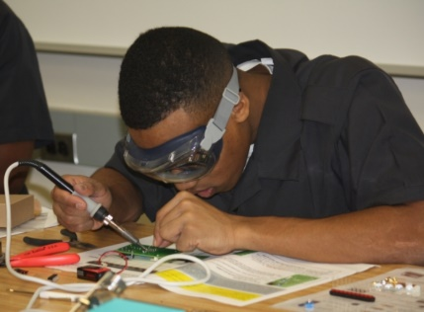The Before we go through the verification methods that will be used, we shall first explain few concepts and then off of those will be based our verification and validation methods.

As previously stated, an oximeter is a device that is designed to measure the blood oxygen level (SpO2%) without making use of any invasive means [9]. One needs to be aware that blood carries oxygen that is then fed to different part of the body to sustain their healthy functioning [9]. This means that if we restrain blood to prevent it from going through a certain part of the body, we shall also expect it to be reflected in the results of the measurements from the pulse oximeter.

A picture containing an electrical and electronic student soldering on a PCB at FEBE (University of Johannesburg).

Neutral’s pulse oximeters are known for having an accuracy of 0.2% [10], This implies that if we decide to use them as a reference device, and aim for that same level of accuracy, then we shall expect our device to display close to the same level of accuracy.

There are various methods that can be used to verify the effectiveness of the pulse oximeter but Based on the findings and our chosen testing approach, we shall focus on the following listed below:

• Testing of measurement sensitivity of input to the signal processing unit.

• Testing of measurement sensitivity of output to the signal processing unit.

• Testing of electrical input to the CPU subsystem.

• Testing of the device accuracy by comparison to the reference device.

• Testing of the measurement of the device in comparison with a more accurate pulse oximeter.

• Comparing measurement from different parts of the body.

• Repeating measurement on the same part of the body.

• Perform tests on healthy female/male adult and compare with measurement from healthy female/male child (10- to 14-year-old).

• Testing for accuracy in case the user has polished nails.

Table : Summary of verification method,

|  |  |  |  |
| --- | --- | --- | --- |
| Nature of verification method | Verification method | Description | Validation method |
| Design functional requirement | Testing of measurement sensitivity of input to the signal processing unit | This method consists in measuring the electrical current/voltage that results from the direct output from the photodiode. | Demonstration and analysis |
| Testing of measurement sensitivity of output to the signal processing unit | This method consists in measuring the electrical current/voltage that results from the direct output from the signal processing unit. | Demonstration and analysis |
|  | Testing of electrical input to the CPU subsystem | This method consists in measuring the electrical current/voltage that results from the direct input value to the CPU as received from the signal processing unit | Test and demonstration |
| Testing of the device accuracy by comparison to the reference calibration | This method consists in observing the output value from the CPU on the LCD screen interface with the output observed from Figure 3: Pulse Oximeter calibration curve [9]. | Inspection |
| Design operational requirement | Testing of the measurement of the device in comparison with a more accurate pulse oximeter | This method consists in using another oximeter with better calibration to check for accuracy of the readings | Inspection |
| Comparing measurement from different parts of the body | This method consists in measuring the SpO2 level on different fingers of the same person with little time frame of interval between each measurement. | Inspection and analysis |
| Repeating measurement on the same part of the body | This method consists in measuring the SpO2 level on the same finger of the same person with little time frame of interval between each measurement. | Inspection and analysis |
| Perform tests on healthy female/male adult and compare with measurement from healthy female/male child (10- to 14-year-old) | This method consists in measuring the SpO2 level on the same finger of the same amount of female and male person with little time frame of interval between each measurement. | Inspection and analysis |
| Testing for accuracy in case the user has polished nails | This method consists in measuring the SpO2 level on the same finger of the same person with different colors of nail polishing with little time frame of interval between each measurement. | Inspection and analysis |

### Calculation of SpO2(%)

Our approach for calculation of SpO2 level includes the pulse oximeter calibration curve as shown below.

Figure : Pulse Oximeter calibration curve [9].

* The plot shown in the figure above assists with pulse oximeter calibration.

Table : Table: showing R values ad their corresponding SpO2 levels.

|  |  |
| --- | --- |
| **R** | **SpO2(%)** |
| 0,4 | 100,6216 |
| 0,5 | 97,8275 |
| 0,6 | 94,6436 |
| 0,7 | 91,0699 |
| 0,8 | 87,1064 |
| 0,9 | 82,7531 |
| 0,1 | 106,6651 |
| 1 | 78,01 |
| 1,1 | 72,8771 |
| 1,2 | 67,3544 |
| 1,3 | 61,4419 |
| 1,4 | 55,1396 |

* Shown In the y-axis is the SpO2 level in percent and the R values are on the x-axis.
* The value of R needs to be calculated from the obtained data before using the calibration equations below.

**Formulae:**

**SpO2=-19.49R2-10.4R+107.9**

### Calculation Heart Rate

As for the heart rate calculations, they shall be performed only using the signal resulting from having only the IR led emitting light onto the photodiode such that the pick of the signal measured can be counted by the Arduino microcontroller to then compute the heart rate in (BPM) which keeping track of the time.

# PCB design

The first step of the PCB design was to come up with an high level architectural diagram.

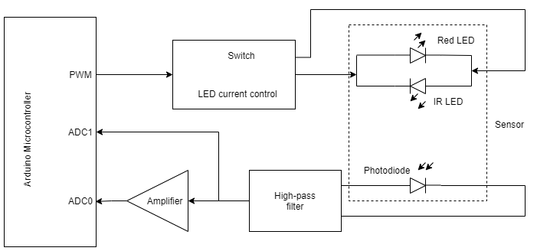

Figure : Architectural Diagram.

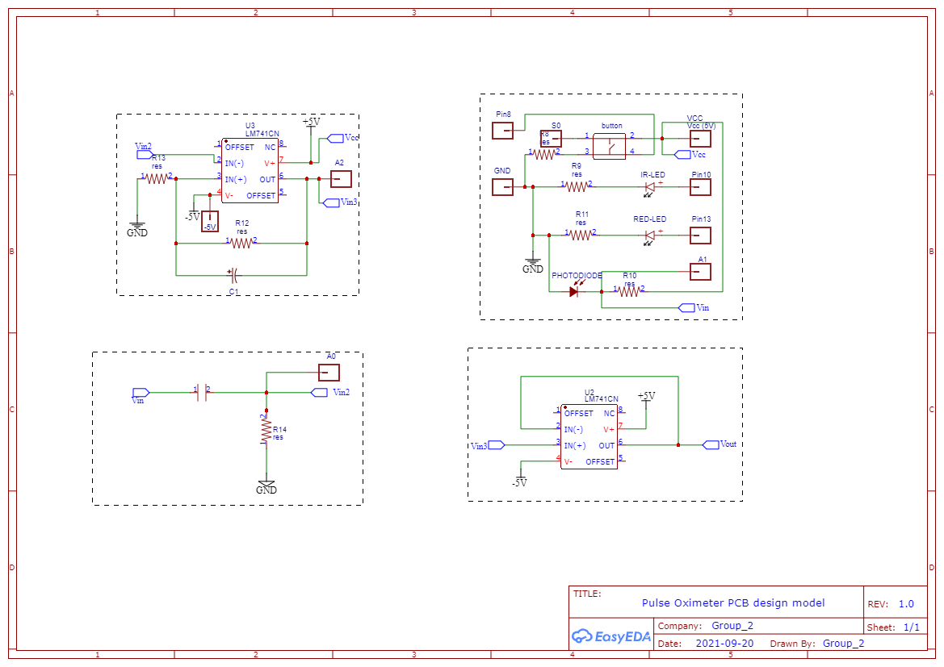The second step of our design included detailing all the components that made up each subsystem.

Figure : Subsystem architectural/circuit diagram.

The next step was to convert the Subsystem circuit into a PCB 2D design which could then be converted into a PCB 3D design using the easyEDA software.

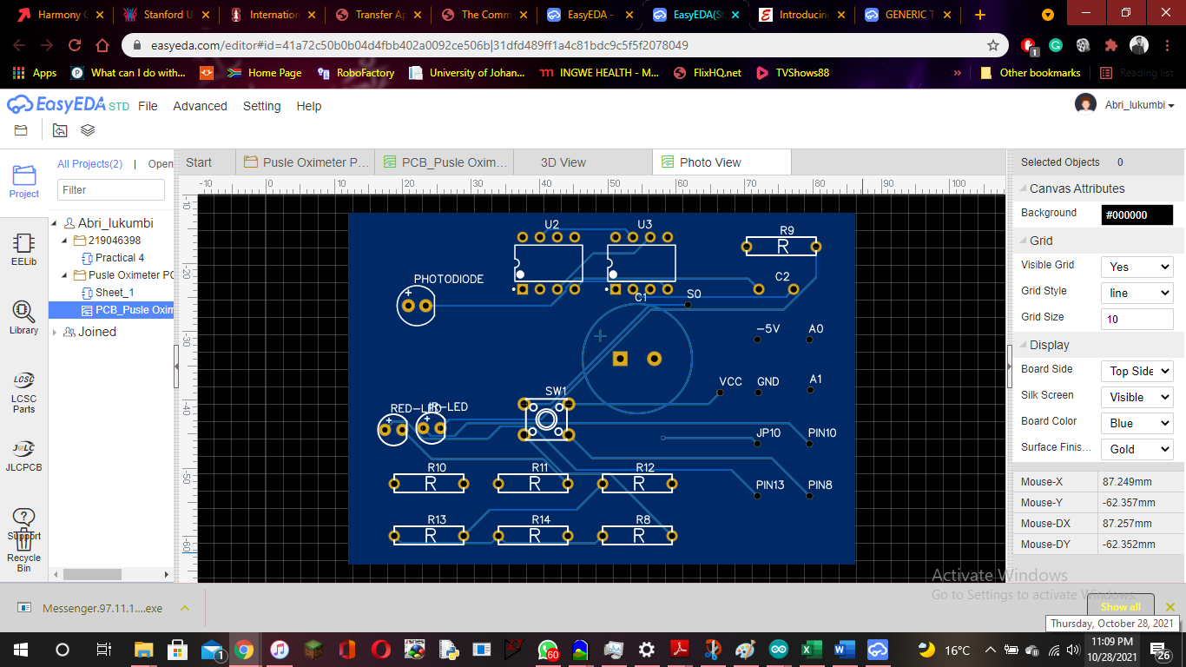

Figure : 2D PCB design.

Figure : 2D PCB design.

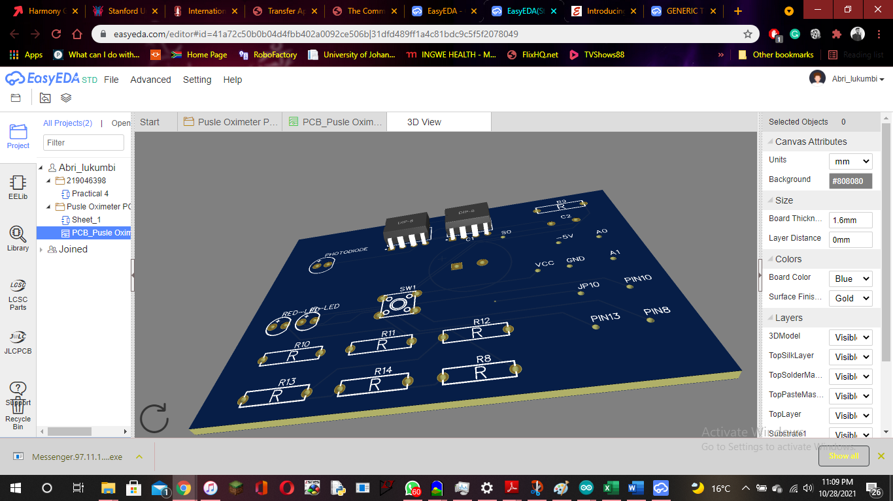

Figure : 3D PCB design view.

# 3-D casing design

Below are shown the 3D casing design of our oximeter device. The design was made using the TinkerCad software.

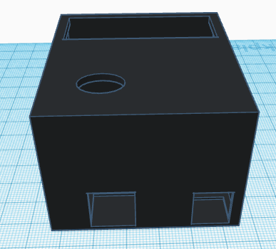

Figure : 3D casing design (view 2).

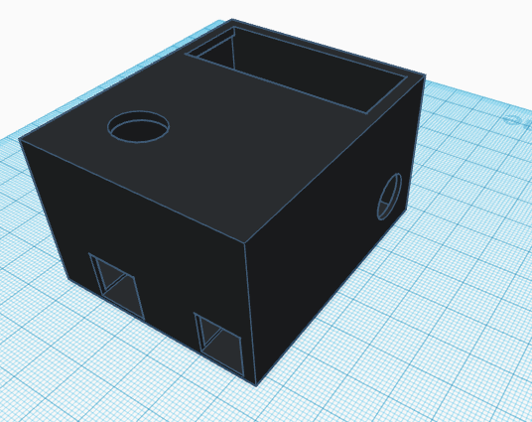

Figure : 3D casing design (view 1).

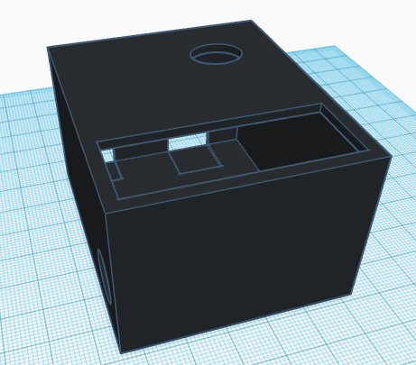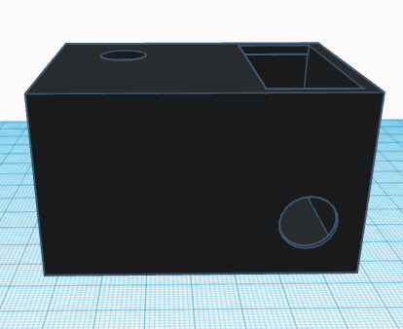

Figure : 3D casing design (view 4).

Figure : 3D casing design (view 3).

The rectangular hole at the top is designed to accommodate an LCD display. The circular hole just below the LCD display hole is designed to allow a finger for SpO2 and heart rate measurements. The two side by side rectangular holes on the side are designed to accommodate the two Arduino power/USB ports.

# References

[1] NeoReviews, “History of Pulse Oximetry in Neonatal Medicine”. [Online]. Available: <https://neoreviews.aappublications.org/content/6/12/e533>

[2] Healthline, “Pulse oximetry”. Available: <https://www.healthline.com/health/pulse-oximetry#purpose-and-uses>

[3] Takealot, “Pulse Oximeter Blood Oxygen Saturation Monitor”. [Online]. Available: <https://www.takealot.com/pulse-oximeter-blood-oxygen-saturation-monitor/PLID65541137>

[4] Lyle E. Kirson DDS, Renee Koltes-Edwards MD, in Anesthesia Secrets (Fourth Edition), 2011. [Online].Available: <https://www.sciencedirect.com/topics/medicine-and-dentistry/pulse-oximetry>

[5] Charles Patrick Davis, MD, PhD ,“Safe, Normal, Low Blood Oxygen Levels: Pulse Oximeter Chart”, May 2021. [Online]. Available: <https://www.onhealth.com/content/1/normal_low_blood_oxygen_pulse_oximeter_levels>

[6] G. Baura, “Chapter 11 - Pulse oximeters”, Medical Device Technologies, 2nd edition, Pages 281-303, September, 2021.

[7] M. Mehrabi, S. Setayeshi, M. Ghannadi Maragheh, S. Hossein Ardehali, H. Arabalibeik, “Design of a new reflectance pulse oximeter by obtaining the optimal source-detector space”, Optik, Volume 168, Pages 34-45, September, 2018.

[8] Electronics Tutorials, 2015. [Online]. Availabe: <https://www.electronicstutorials.ws/filter/filter_6.html>

[9] AIP Conference Proceedings 1883, 020024, “Development of theoretical oxygen saturation calibration curve based on optical density ratio and optical simulation approach”, [Online], September 2017. Available: <https://doi.org/10.1063/1.5002042>

[10] “8888 Oxygen Oximeter Pulse Oximeter”, [Online]. Available: <https://za.rs-online.com/web/p/gas-detectors/2020776/?cm_mmc=ZA-PLA-DS3A-_-google-_-PLA_ZA_EN_Test_%26_Measurement_Whoop-_-(ZA:Whoop!)+Gas+Detectors+(2)-_-2020776&matchtype=&aud-827186183926:pla-302917891561&gclid=CjwKCAjw-ZCKBhBkEiwAM4qfF4JplGJPDW_gU0KmLNs2mEePgdSlXZpKMPlgGPwrYK8kxygZ2G4-6xoCar8QAvD_BwE&gclsrc=aw.ds>